OPERATING PROCEDURES/GUIDELINES

ON-SITE WASTEWATER TREATMENT & DISPOSAL

The first goal is to ensure that all new housing be equipped with an approved septic system (tank, lines & secondary treatment), and that efforts be made to inform citizens of the county on health hazards relating to septic systems, aware of their existing systems, and the county regulation.
These procedures/guidelines may require additions as new questions or circumstances arise. They will be reviewed yearly in January or February prior to the construction season beginning. They will provide guidance to the Sanitarian to ensure that everyone asking a similar question gets the same answer. Not all sites are alike though, and may require limited variations.
- New construction requires an application be filled out and a permit issued prior to a contractor starting work on the septic system.
- Existing septic systems that requiring digging, the Sanitarian will be notified. Replacement of short sections of pipe will not require a permit but if the tank has to be replaced, a permit will be needed and the entire system upgraded. If the existing secondary treatment system fails or if the entire discharge line from a tank has to be replaced creating a new direct discharge, then the entire system shall be upgraded.
- The application for permit shall be filled out completely including a drawing of proposed site on back of application.
- Uncovering a septic tank to have it pumped is considered maintenance, no notification or permit is needed.
- Rebuilding of a home or moving a manufactured home onto a site with an existing system will be considered the same as new construction. This may require upgrading or replacement of the existing system if it does not meet current State and County regulations.
- In upgrading a system, if the tank is found to be in acceptable condition but too small or containing only one compartment, another tank could be put with it to meet requirements.
- If just adding another bathroom, upgrading of system not necessary.
- As the Sanitarian is not always available, notification for final inspection is needed in advance. Special arrangements may be needed.
- If request is made for a time of sale inspection, both parties must agree to the inspection. If an inspection is done and the system is found to be inadequate, the system would require upgrading.
- Anyone wanting to install an alternative type system will need approval of the Board of Health. The board could then allow the Sanitarian to approve future systems of the same type, or require their approval on each system. These variances could also require written agreements between owner and Board of Health addressing testing, failure or poor results of the system. The owner shall see that this agreement is recorded with the County Recorder, in the abstract of title for the property containing the alternative system.
- Contractors doing septic work will “register” with the Sanitarian to be on a list provided to individuals along with application. This would mean they understand the county regulations and agree to follow them.
- When a system requiring a service agreement is installed, it will be the responsibility of the owner to see that the service agreement (original copy) is recorded with the County Recorder, in the abstract of title for the property containing the system, within thirty days after inspection. A service agreement shall be maintained at all times.
- The individual, contractor or company that is providing the maintenance agreement is responsible for testing the effluent at the required times with a copy of the results being submitted to the Sanitarian.
- When planning your septic system, consideration should be given to its location, future plans and required distance requirements. Anyone planning to do their own work shall discuss their site with the County Sanitarian prior to starting the work to make sure they understand all of the requirements. The Sanitarian can do a site preview with the contractor and/or homeowner prior to the work being done.
- If a system is installed which has a surface discharge, that discharge shall be on your own property within distance requirements from property lines, easement areas, etc. Systems should discharge away from road ditches. If a road ditch is the only option, a permit shall be obtained from the road authority to perform work in the road right-of-way.
- Any dwelling where plumbing does not exist shall be served by an impervious vault toilet meeting the requirements of IAC 567-69.13(455B). Any dwelling with plumbing (drains from a sink, tub, etc.) that discharges water out of the dwelling shall be served by an on-site septic system consisting of a primary and secondary treatment system as required per IAC 567-69.1(455B). If the dwelling does not contain a toilet connected to the plumbing system, the dwelling shall also be served by an impervious vault toilet meeting the requirements of IAC 567-69.13(455B).
- There is a low interest loan program available for those who qualify. This program is intended for those sites that currently have improper septic systems and have to or want to upgrade their system. It is only available for unincorporated portions of the county. Ask for information on the Onsite Wastewater Assistance Program (OSWAP).
- There may also be grant money or low interest funds available from USDA Rural Development. These are generally based on your income and age. Ask for information on these programs.

LIST OF LOCAL CERTIFIED WELL PLUGGING CONTRACTORS

This list is maintained by the Iowa DNR: https://programs.iowadnr.gov/opcertweb/pages/oper_search.aspx

Options for Secondary Treatment Systems

Subsurface Absorption Systems – Soil absorption systems are the best available treatment technology and shall always be used where possible. A percolation test or professional soil analysis is required before any soil absorption system is installed. There are different types of absorption systems – gravel system and chamber system.
Mound System – Mound systems shall be permitted only after a thorough site evaluation has been made and landscaping, dwelling placement, effect on surface drainage and general topography have been considered.
*The following systems generally have a surface discharge and may require a NPDES permit. The NPDES permit will specify the sampling frequency. If the system is designed with no discharge, then the NPDES permit and sampling is not required.
Intermittent Sand Filter System – Subsurface sand filters may be used when the site is unacceptable for a soil absorption system.
Constructed Wetlands – Constructed wetlands shall only be used when the site is unacceptable for a soil absorption system. Because of higher maintenance requirements, preference should be given to sand filters, where conditions allow. The effluent from a constructed wetland shall receive additional treatment through the use of sand filters.
Individual Mechanical Aerobic System – Mechanical aerobic systems may be used when the site is unacceptable for a soil absorption system. Because of higher maintenance requirements of the mechanical aerobic systems, preference should be given to sand filters, where conditions allow. There are different brands of mechanical aerobic systems and they shall all be certified. A maintenance contract with a manufacturer-certified technician shall be maintained at all times.
Impervious Vault Toilets (Outhouses) – Impervious vault toilets may be used if designed and constructed in accordance with Chapter 69.
Peat Filters & Re-circulating Textile Filters – May be used when the Administrative Authority determines the site is unacceptable for a soil absorption system. There are different brands and they require a maintenance contract.

Alternative or innovative systems are to be designed and operated in accordance with approved standards and operating procedures established by the administrative authority.
Every on-site system, except mechanical-aerobic systems, shall have, as a primary treatment unit, a septic tank meeting state’s requirement. Size is based on the number of bedrooms for homes and water usage for businesses. Tank size shall increase if high volume water use fixtures are used.
Homeowners are responsible for the maintenance, care and proper functioning of their septic system. This includes maintaining maintenance contracts with service providers for those types of systems that require maintenance contracts.

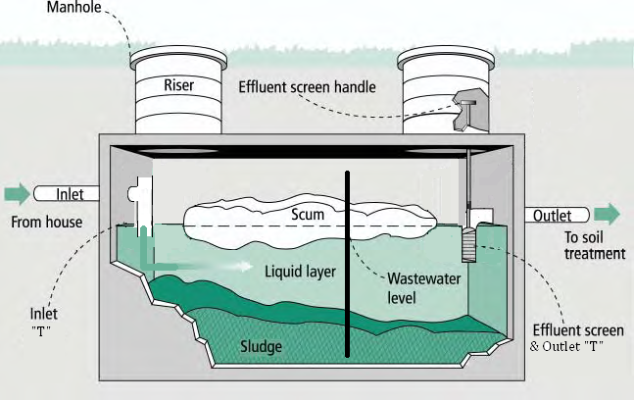
Shall be 4”sch. 40 pipe & shall extend at least 6” above & 8” below liquid level.(No more than 20% of liquid depth.)

Shall be 4” sch. 40 pipe & shall extend at least 6” above & at least 10” below liquid level. (No more than 25% of liquid depth.)

Every septic tank shall be divided into 2 compartments. This may be obtained by using more than 1 tank. Influent compartment shall not be less than ½ nor more than 2/3 of total capacity. Effluent compartment shall not be less than 1/3 nor more than ½ of total capacity. Any tank placed in fill soil shall be placed on a level, stable base that will not settle. Access must be provided to all parts of tank necessary for adequate inspection, operation & maintenance. If only 2 opening in tank located over inlet & outlet. They must be at least 18”. A 24” diameter opening may be provided at the center of tank with 2 smaller openings of at least 6 “over the inlet & outlet. If top of tank is more than 12 “below finished ground level, a riser at least 24” in diameter must be installed over each manhole of 18” or more in diameter to ring the top of the manhole lid to within 6” of the finished ground level.
- Tank shall not be used for disposal of chemical wastes or grease in quantities, which might be detrimental to the bacterial action in the tank.
- Interior length of tank should not be less than 5’ & shall be at least 1 ½ times the width. No tank or compartment shall have an inside width of less than 2’. The minimum inside diameter of a vertical cylindrical septic tank shall be 5’.
- Minimum liquid depth shall be 40”. Maximum liquid depth for calculating capacity shall not exceed 6 ½’.
- Tanks shall be constructed of poured concrete or plastic resistant to corrosion or decay & designed so they will not collapse or rupture. Metal tanks are prohibited Fiberglass or plastic tanks shall be bedded according to manufacturer’s specifications.
- Inlet and outlet connections at the tanks shall be made by self-sealing gaskets cast into the concrete or formed into the plastic or fiberglass
Tank capacity
3 bedroom or less | 1,250 gals
4 bedrooms | 1,500 gals
5 bedrooms | 1,750 gals
6 bedrooms | 2,000 gals
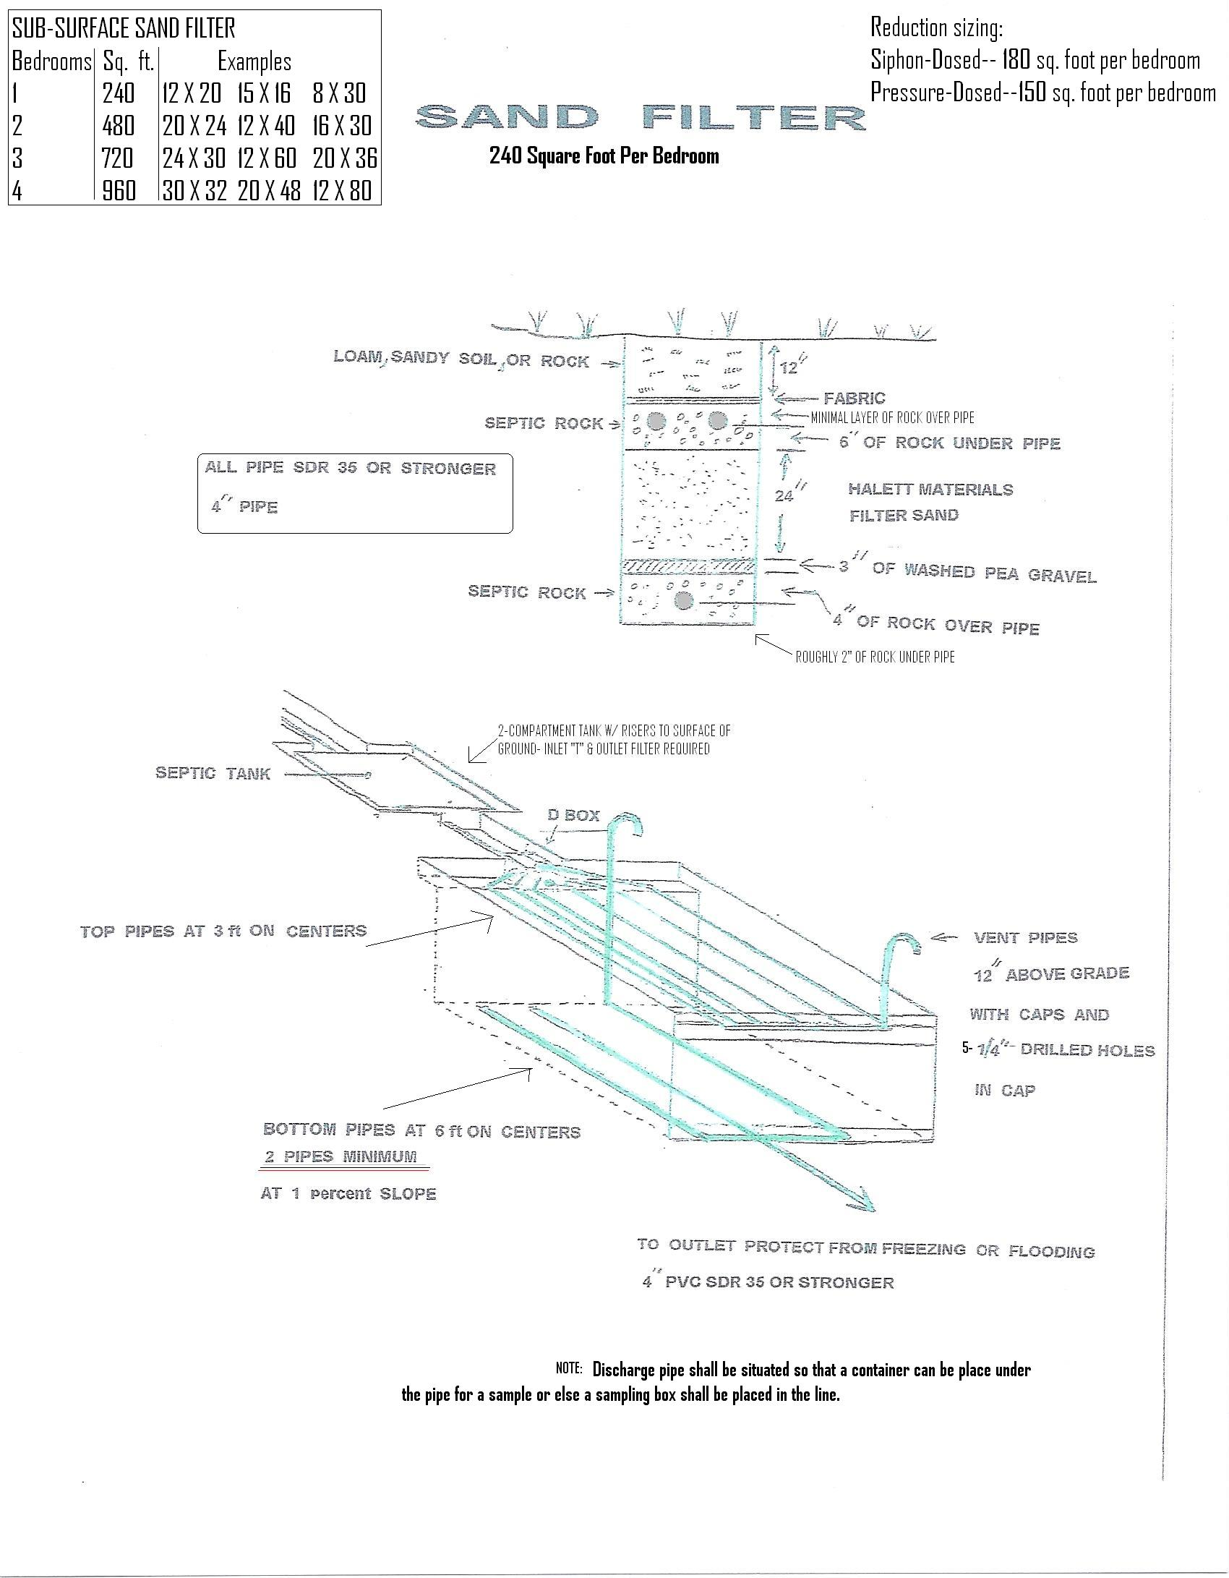
Sub-surface sand filter-based on chapter 69 guidelines
- For residential systems, subsurface sand filters dosed by a dosing siphon shall be sized at a rate of 180 square feet of surface area per bedroom and those dosed by a pump shall be sized at 150 square feet of surface area per bedroom.
- All materials are to be clean and washed. Sand shall meet Iowa DOT standards for concrete sand, pea gravel is to be 1/8 to 3/8 inch in size and the septic rock is to be ¾ to 2 ½ inches in size.

Constructed Wetland
40’ pipe extended from wetland
Undisturbed soil approx. 2’wide
River gravel over discharge pipe
Coarse Sand
2’ deep
All river gravel ¾” to 2 ¼”
Constructed Wetland
3’
18”
15’
6”
3’

May be in trenches or beds-300 sq ft per bedroom.
(45 sq ft) sand filter required following any constructed wetland system

SEPTIC TANKS
LIEBUS CONCRETE PRODUCTS—1-800-491-6869 115 8TH Ave EAST – Oskaloosa, Iowa

LISTER INDUSTRIES ---– Phone – 515-244-3149 300 NW 48TH PL. – Des Moines, Iowa

PRE-CAST CONCRETE COMPANY—-641-782-4515 622 ½, New York Ave. –Creston, Iowa

INDIANOLA PRECAST- 515-961-5158/515-865-8815 12995 80th Ave--- Indianola, IA

YODER’S PRECAST LLC- 641-898-2803 2874 210th St--- Seymour, IA

Soil Borings, Soil Analysis
Jim Carroll,PE Clive, IA
515-250-2103

Choquette Engineering-Ken Choquette, PE Des Moines, IA
515-306-0019/265-8681

Stiens Soil Evaluations-Chris Stiens Maryville, MO
(660)-562-0726

Lee Engineers & Surveyors-Wally Greenlees Urbandale, IA
(515)252-7457

ABACI Consulting, INC Grimes, IA
(515)986-5048

Douglas Oelmann Altoona, IA
(515)419-2926

Camron Collier, PE Grand River, IA
(515)238-6330/641-414-4669

TRAINED SERVICE/MAINTENANCE PROVIDERS

Bedwell Builders: Ben Bedwell, 2924 Quaker St, St Charles, IA; 515-681-2053

Derry Construction Inc.: Brad Derry; 1600 210th St, New Market, IA 51646; (712)370-1547

J&H Construction: Josh Jackson; 1410 Grade Lake Drive, Osceola, IA 50213; (641) 414-3171

Mike’s Construction & Excavating LLC: Mike Yutzy: 18659 270th Ave, Leon, IA 50144; (641) 344-7220

Molitor Construction LLC: Paul Molitor: 1246 Noble Hills Place., Boone , IA 50036; (515)298-1268

O.W.W.T, LLC: James Carney: 1541 NE 66th Ave, Des Moines, IA 50313; (515) 244-4646

Rogers Septic LLC: Rick and Brandon Rogers, 401 NE 52nd Ave, Des Moines, IA 50313; 515-282-0777

Snyder Plumbing LLC: Gerald Snyder: 1817 Shore St., Truro, IA 50275; (641)342-8579 (515)975-2594

Southern Iowa Plumbing, LLC: John Buttz: 411 N Dotur Dr. Corydon, IA 50060; (641)870-1640

This is not a complete list. This list is just a few that we know of that do work in the county or supply materials needed in septic construction.

Licensed Septic Pumpers
Cannon’s Porta John Rentals  Greg Cannon-202 N. Grant St. Mt Ayr | 641-464-2906/641-344-7343  Truck holds up to 375 Gallons
Page Construction  Mike Page, Shannon City | 641-340-1888  Truck holds up to 2000 Gallons
Rauch’s Septic Service  Eddie Rauch- 13326 205th St. Lamoni | 641-773-5351  Truck holds up to 2500 Gallons
Anytime Septic Services II, 502 W. Main St. St. Charles | 641-396-2440  Truck holds up to 2500 Gallons
Dave’s Pumping Service, 1685 Upland Trail Prole | 515-462-1903
Don’s Jons LLC, Craig Shippley - PO Box 88, Lineville | 800-944-2317/660-953-1611  Truck holds up to 900 gallons
Forest Septic Tank Service, Po Box 219 Indianola | 515-961-2113  Truck holds up to 4500 Gallons
Lathrop Farms, 6921 219th Trail Albia | 641-777-3774
Mike Killen Construction, 1679 140th Ave Carlisle | 515-480-6082  Truck holds up to 2200 Gallons
RM Plumbing & Construction, Robert McCaulley, Lucas | 515-321-6623  Truck holds up to 2,000 gallons
Southern Iowa Plumbing, LLC, John Buttz- 411 N Dotur Dr, Corydon | 641-870-1640  Up to 2,000 gallons
Wiegert Disposal Inc, PO Box 344 Martensdale | 641-764-2389  Up to 5,000 gallons
Willets & Woosley Sewer & Septic, 411 New York Ave Creston | 641-782-4220  Truck holds up to 1,700 gallons
This is not a complete list. This list is just a few that we know of that do work in the county.

