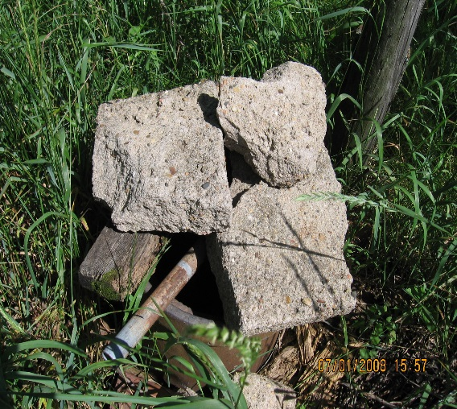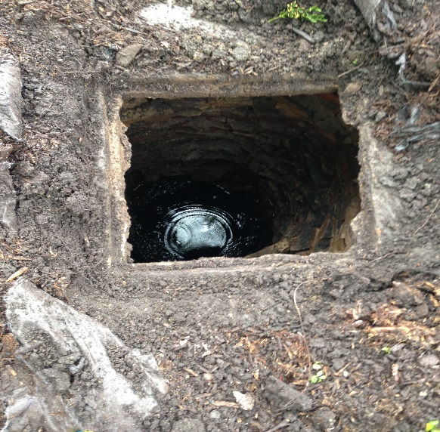

**Contact Information**

Ringgold Environmental Health

109 W. Madison St.

Mt Ayr, IA 50854

641-464-0691

***Certified well plugging contractors are available on our website or***

***For a full list, please visit*** [***www.iowadnr.gov***](http://www.iowadnr.gov)

*Cost share assistance is available for plugging wells. There is a grant program that provides cost share reimbursement to help pay some (or all) of the cost associated with plugging your abandoned water supply well(s). The Grants-to-Counties Program is a program funded by the Groundwater Protection Act and administered by the Iowa Department of Public Health. All qualifying well services funded by the Grants-to-Counties cost share program must be performed by an Iowa DNR Certified Well Contractor.*

*Clarke & Decatur County cover up to $500 for the cost of plugging a well and $300 for the cost of filling a cistern.*

It’s the LAW

The law that requires abandoned wells to be properly plugged is found in Iowa Code [455B.190](http://coolice.legis.iowa.gov/Cool-ICE/default.asp?category=billinfo&service=IowaCode&ga=83&input=455B.190) - "Abandoned wells properly plugged."

The actual rules that prescribes how each well must be plugged are found in the Iowa Administrative Code 567 [Chapter 39](https://www.legis.iowa.gov/docs/iac/chapter/01-03-2018.567.39.pdf), "Requirements for Properly Plugging Abandoned Wells."

**The term "abandoned well" means a water well which is *no longer in use*, or the well is in such a state of disrepair that continued use of the well for the purpose of accessing water is unsafe or impractical.**

**FREE ASSISTANCE**